|  |  |  |
| --- | --- | --- |
| 03-03-2017 |  | Use Case Diagram |
|  |  |  |

# USER

Project’s Name

MyCook

Project Manager

Professor Miguel Cruz

Student

Ângela Barros

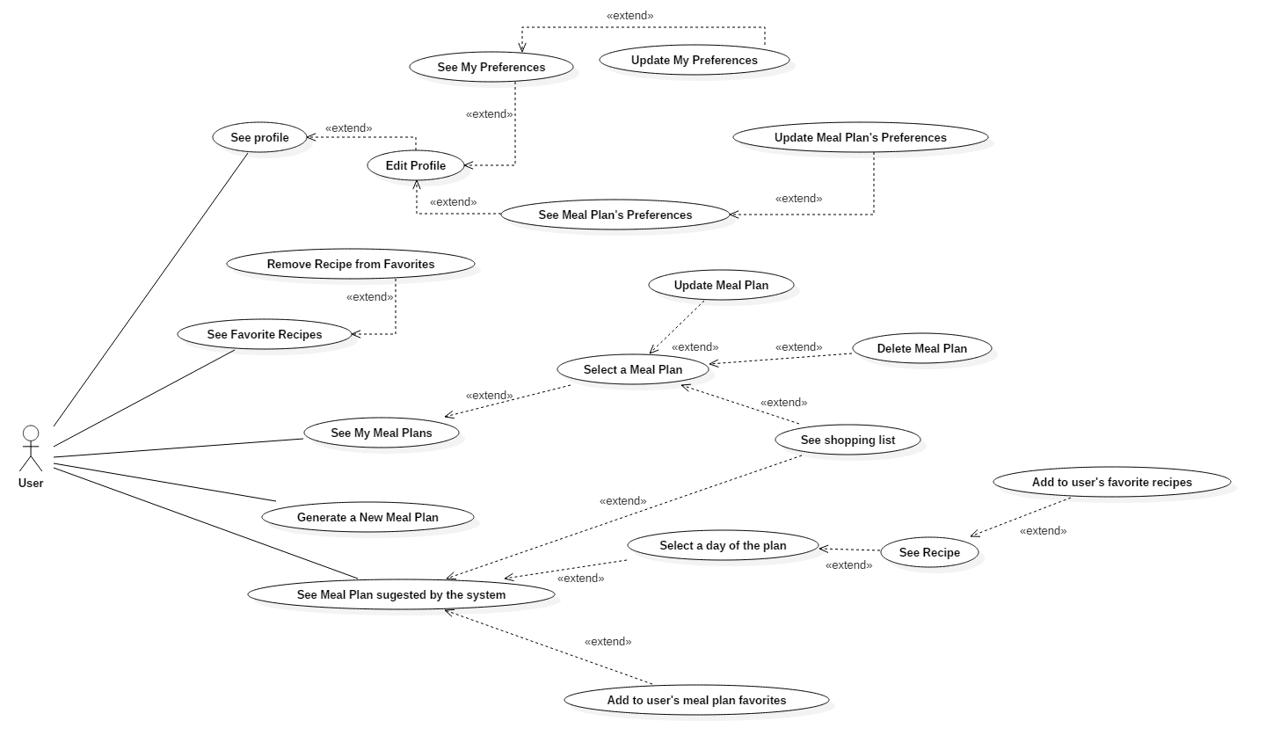

# ADMIN

